Recommendations:

If only Gender is given about Customer:

 - Female prefer entry level

 - Males prefer advanced level

Probabilities:

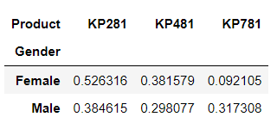

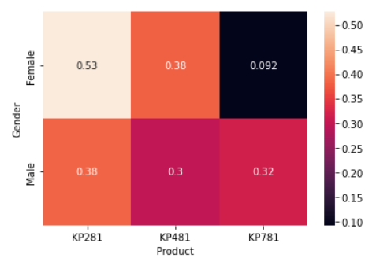

If only Marital Status is given about Customer:

Pretty much in every product single and partnered have equal probability to buys.

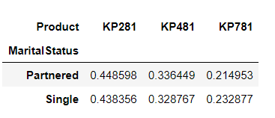

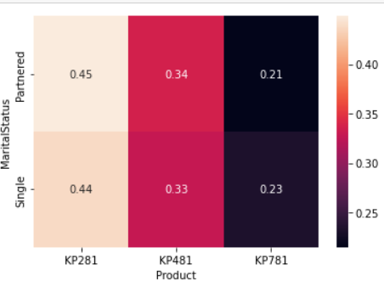

If we have Both Gender and Marital Status.

- Partnered Female have more probability to buy KP281

 - Single Female have more probability to buy KP481

 - Single Male have more probability to buy KP781 , Also Partnered Male have almost same probability.

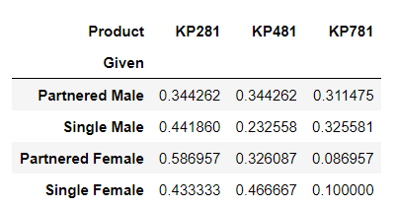

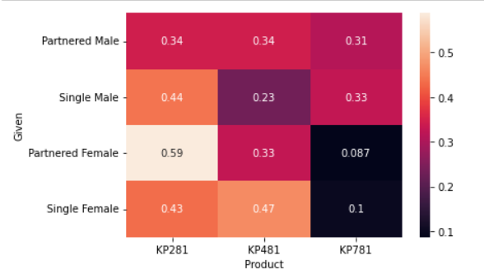

If Income, Gender and marital status  is given for the customers.

For Male irrespective of any factors who have income greater than median income of dataset prefers the advanced level product, But in female irrespective of income or married , Probability of buying entry level model is high.

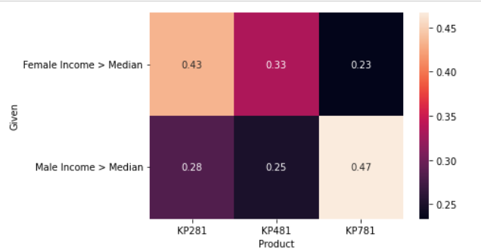

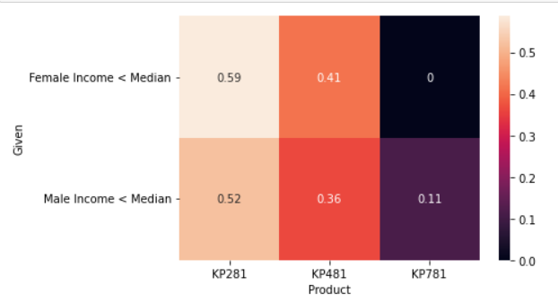

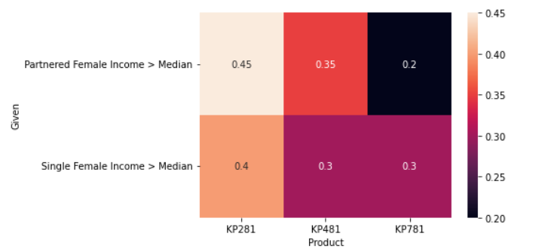

If Customer have education more than 16 years always prefer advanced model irrespective of other factors.

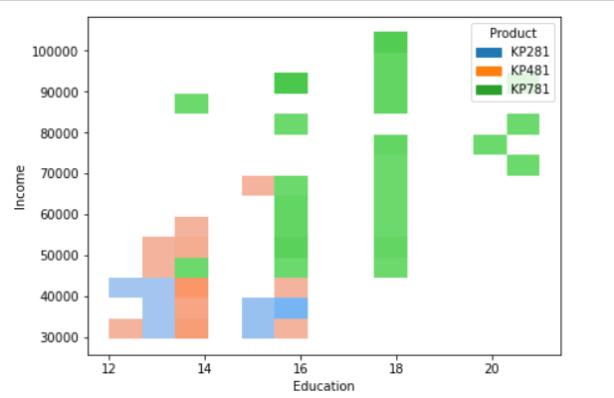

If Customer have income greater than 70,000 purely buys advanced level product.

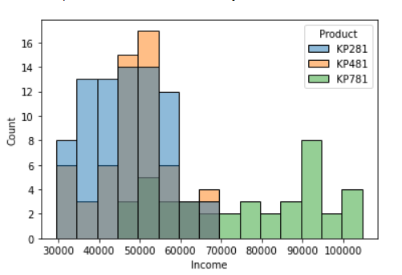

Customer Recommendations to improve the fitness level.

As we saw the fitness level is most correlated with Miles.

We can recommend the customer to run this many miles to achieve . for example if customer wants minimum miles to be run for fitness to be 4 , we can say atleast 125 miles.

